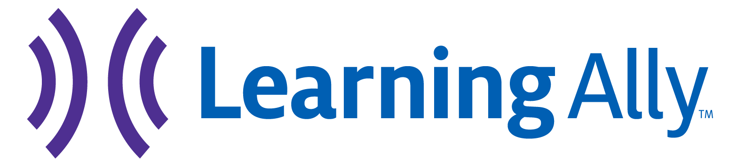

LOCAL PRESS RELEASE TEMPLATE

School Name or Student Name Wins the Great Reading Games,
Learning Ally’s National Reading Event

(OR)

School Name or Student Name Was a Top Finisher in the Great Reading Games, Learning Ally’s National Reading Event

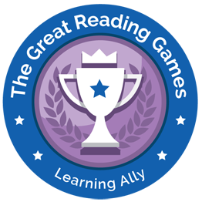
Month Day, 2019 – (City, State) – School Name (OR) Student Name in School District Name finished in first place (OR) was a top-ten finisher in the Great Reading Games, a national audiobook event hosted by Learning Ally, a New Jersey-based educational solutions organization.

The annual event coincides with the National Education Association’s Read Across America to empower students in grades 3-12 with learning differences to read with frequency and build strong reading habits.

This year, more than 37,000 students from 1,600 U.S. schools read a record-breaking 12 million pages. School Name (OR) Student Name won in their school bracket (OR) grade-level bracket for reading (fill in number of pages if known) pages.

Top schools win Chromebooks, headphones and recognition for their schools. Top students win gift cards and other Learning Ally prizes.

THE QUOTE BELOW IS A PLACEHOLDER. FEEL FREE TO USE THIS OR PLUG IN YOUR OWN QUOTE.

“I couldn’t be prouder,” said Principal Name. “I want to congratulate our students (OR) Student Name for their (OR) his/her outstanding efforts. I also want to congratulate and thank our (OR) his/her teachers who work tirelessly to support their students and instill in them a passion for reading and learning.”

Students who compete in the Great Reading Games are three times more likely to excel in reading frequency and 300% more likely to achieve levels of success that tie directly into their academic achievement, and emotional and social well-being.

Alternative text for participating schools that didn’t finish in the top 10 that can replace text in the beginning/above.

School Name Celebrates Its Students’ Participation in the Great Reading Games, Learning Ally’s National Reading Event

Month Day, 2019 – (City, State) – School Name (OR) District Name recognizes its students for their participation in the Great Reading Games, a national audiobook event hosted by Learning Ally, a New Jersey-based educational solutions organization.
School Name’s students read [fill in number of pages read if known] during the seven-week challenge, which saw more than 37,000 students from 1,600 U.S. schools read a record-breaking 12 million pages.
The Great Reading Games is designed to empower students in grades 3-12 who struggle with reading. The goal of the event is to get students reading with frequency, which Learning Ally defines as reading for twenty minutes a day for thirty-three days.

Add School Boilerplate

About Learning Ally
Learning Ally is a leading education solutions organization dedicated to transforming the lives of struggling learners. Our proven Audiobook Solution includes high quality, human-read audiobooks that align to schools’ curriculum in grades 3-12 and a suite of educator resources to help students who struggle to read due to learning differences succeed in school and beyond. Today, Learning Ally is successfully used in more than 16,000 schools nationwide. To learn more visit Learning Ally.org.

Learning Ally Media Inquiries, contact: vChernek@LearningAlly.org

